[VITyarthi Evaluated Course Project]
Apoorva.26bce10875@vitbhopal.ac.in
STUDENT EXPENSE TRACKER
26BCE10875-->apoorva dixit
2026

INTRODUCTION

NAME-APOORVA DIXIT
REGESTRATION NUMBER-26BCE10875
MAIL-> apoorva.26bce10875@vitbhopal.ac.in
SLOT-A21+A22+A23+B14+D21+D22
FACULTY/PROFESSOR- Dr.VENKAT PRASAD PATHY

Student Expense Tracker: A Python-Based Personal Expense and Budget Management System

PROBLEM STATEMENT:
Students often make several small daily purchases such as food, transportation, shopping, educational materials, and mobile recharges. Because these expenses are usually not recorded systematically, students may find it difficult to understand their spending patterns or determine whether they are staying within their monthly budget.
As a student, I personally face this problem on a daily basis. I often find it difficult to keep track of how much money I have in my wallet, where I spend it, and how much I have left. Small expenses such as food, transportation, shopping, and other daily needs can quickly add up without me realizing it. Having a simple system to record my expenses, monitor my spending, and set a budget would make managing my money much easier and more organized. This personal experience inspired me to develop a Student Expense Tracker that can help students keep track of their expenses and manage their budgets effectively.

Objectives
- To provide an easy way to record daily expenses.
- To organize expenses into different categories.
- To allow users to search and manage expense records.
- To calculate monthly spending automatically.
- To allow students to set and monitor a monthly budget.
- To generate spending reports.
- To provide visual analysis of expenses using charts.
- To reduce manual calculation and improve expense tracking

FUNCTIONAL REQUIREMENT

1. Expense Management
The system should allow students to manage their daily expenses.
- Add a new expense with date, amount, category, and description.
- View all recorded expenses.
- Delete an expense when it is no longer required.
- Search or filter expenses to find specific records.
- Store all expense details safely in the database.
2. Expense Categorization
The system should organize expenses into different categories to make spending easier to understand.
- Categories include Food, Transport, Education, Shopping, Entertainment, Hostel, Recharge, and Other.
- Each expense should be assigned to one category.
- The system should calculate the total amount spent in each category.
- This helps students identify where most of their money is being spent.
3. Budget Management
The system should allow students to set and monitor a monthly budget.
- User can enter a monthly spending limit.
- The system should calculate the total amount spent during the month.
- It should show the remaining budget.
- If spending reaches or exceeds the budget, the system should display a warning.
- This helps students control unnecessary spending.

4. Expense Analysis and Reports
The system should analyze the stored expense data and provide useful summaries.
- Calculate the total monthly expenditure.
- Display spending based on categories.
- Provide a monthly expense summary.
- Compare the user's spending with the set budget.
- Display important information in an easy-to-understand format.
5. Data Visualization
The system should present expense information using charts.
- Generate a bar chart showing spending by category.
- Make it easier for students to identify their highest spending areas.
- Convert numerical data into a simple visual representation.
6. Data Validation and Error Handling
The system should prevent incorrect information from being entered.
- Amount should be a valid positive number.
- Date should follow the required format.
- Category should be selected from the available categories.
- Budget should be a positive value.
- The system should display an appropriate error message when invalid data is entered.
7. Database Storage
The system should permanently store expense and budget information.
- Use SQLite to store data.
- Each expense should have a unique ID.
- Data should remain available when the application is closed and opened again.
- The database should allow the application to add, retrieve, search, and delete records.

Non-Functional Requirements
1. Usability:
The application should have a simple interface that can be easily understood by students.
2. Performance:
Expense calculations and searches should be completed quickly.
3. Reliability:
Expense information should be stored consistently in the database.
4. Maintainability:
The application should use separate modules so that individual components can be modified easily.
5. Error Handling:
Invalid dates, negative amounts, and incorrect budget values should be rejected with meaningful messages.
6. Resource Efficiency:
SQLite provides lightweight local storage without requiring a separate database server.

SYSTEM LAYOUT
START
↓
Display Main Menu
↓
Select Option
↓
Add / View / Calculate / Search / Delete
↓
Process User Input
↓
Update Expense List
↓
Display Result
↓
Return to Main Menu
↓
Exit
↓
END
SCREENSHOT OF INPUT AND OUTPUT AND THE PROCESS

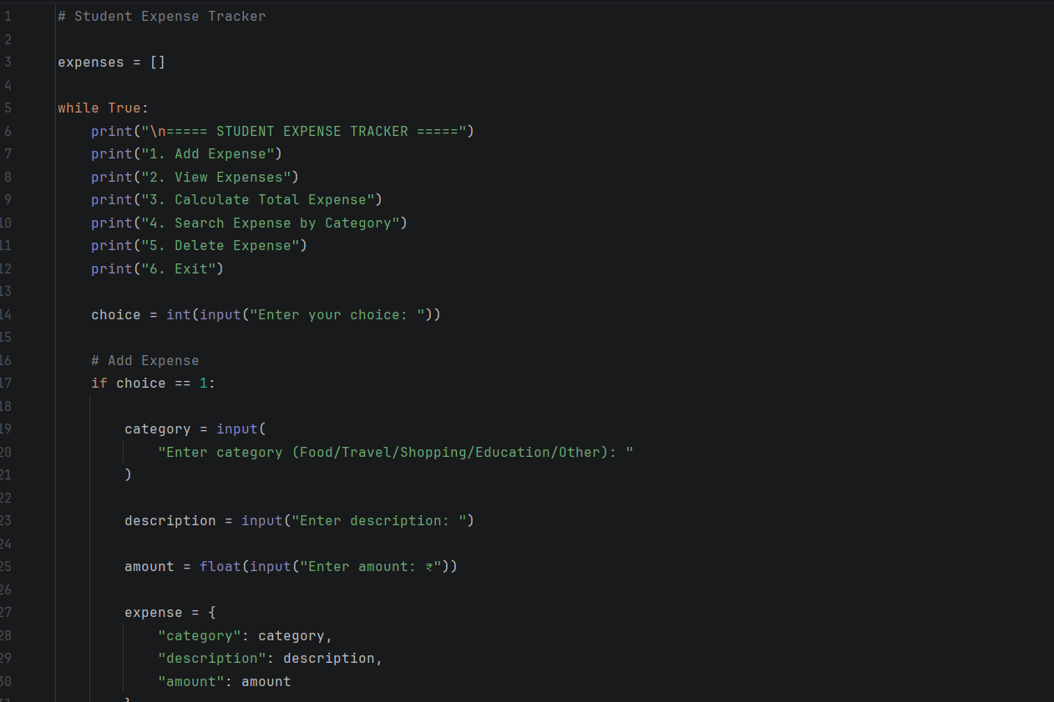
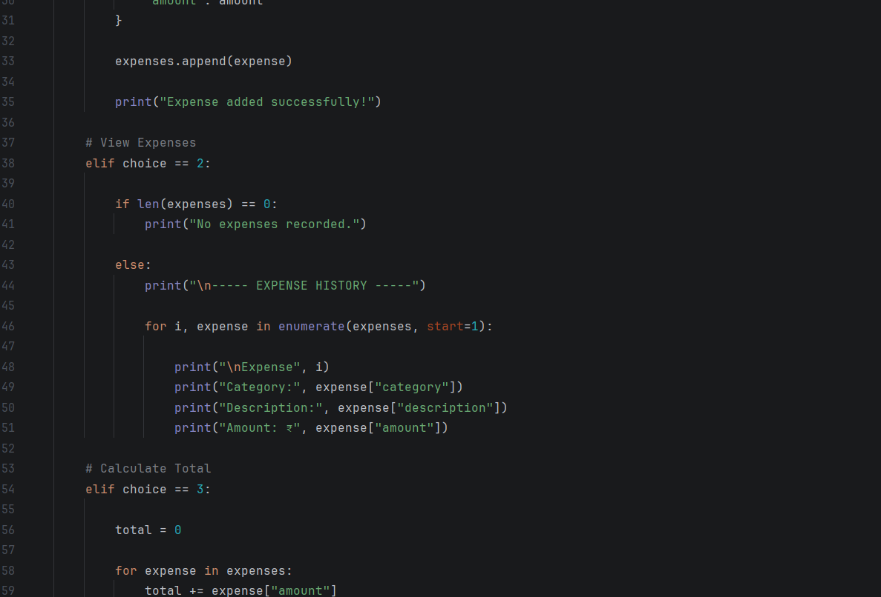
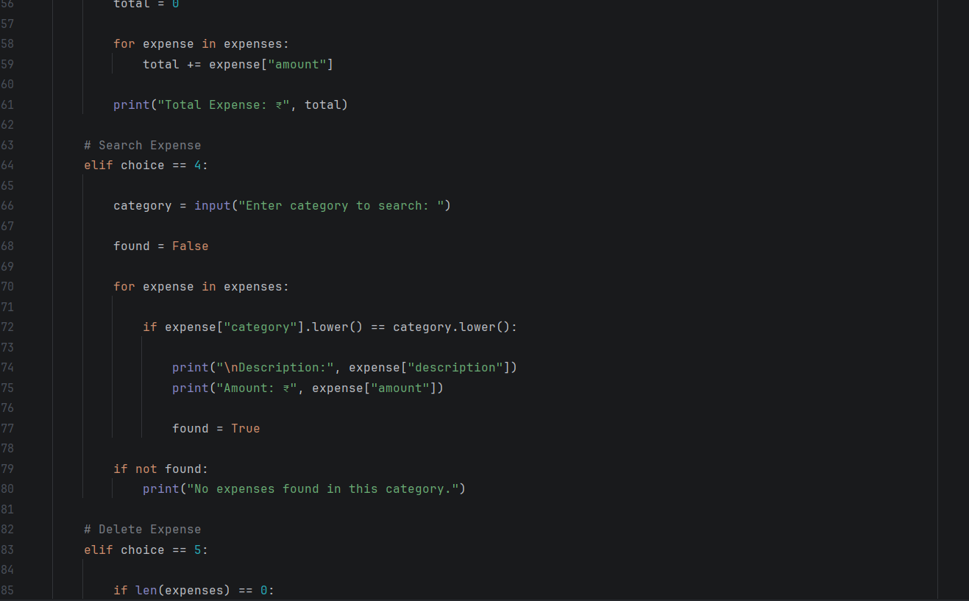
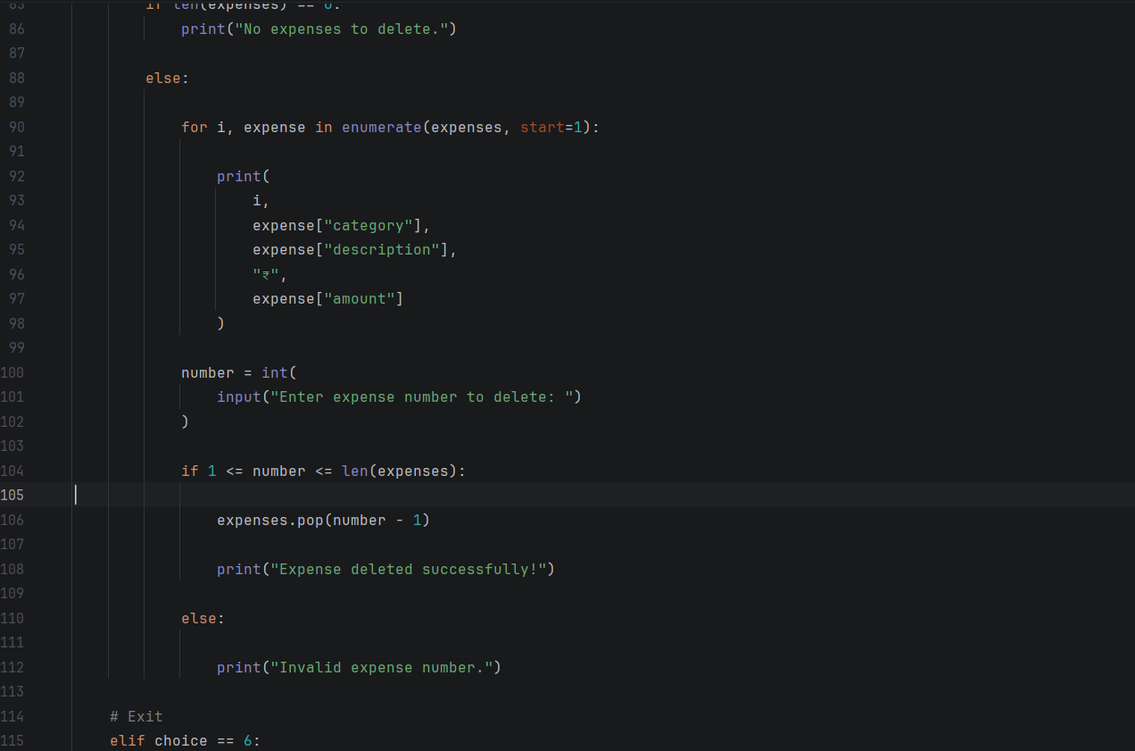
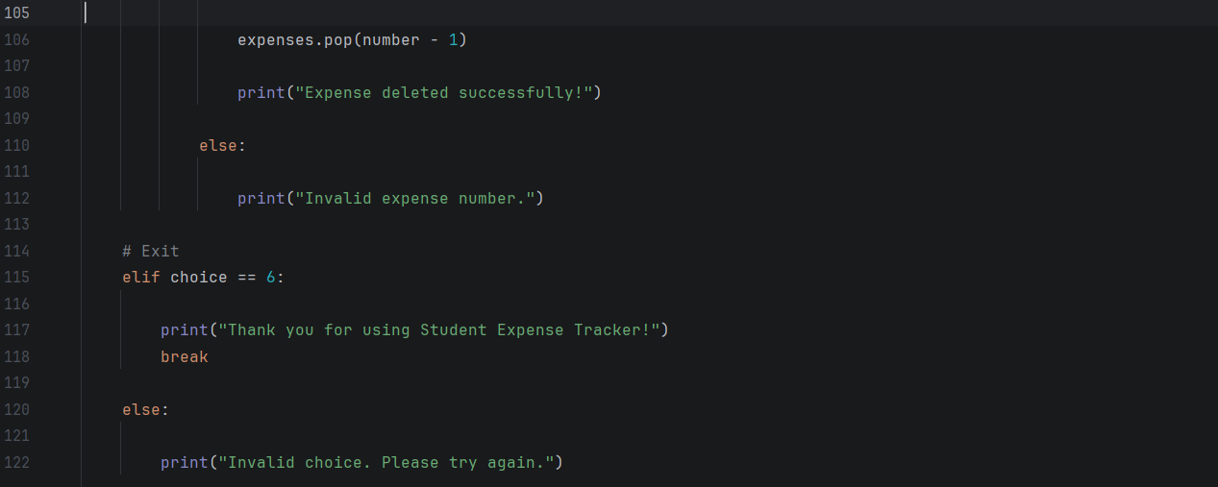
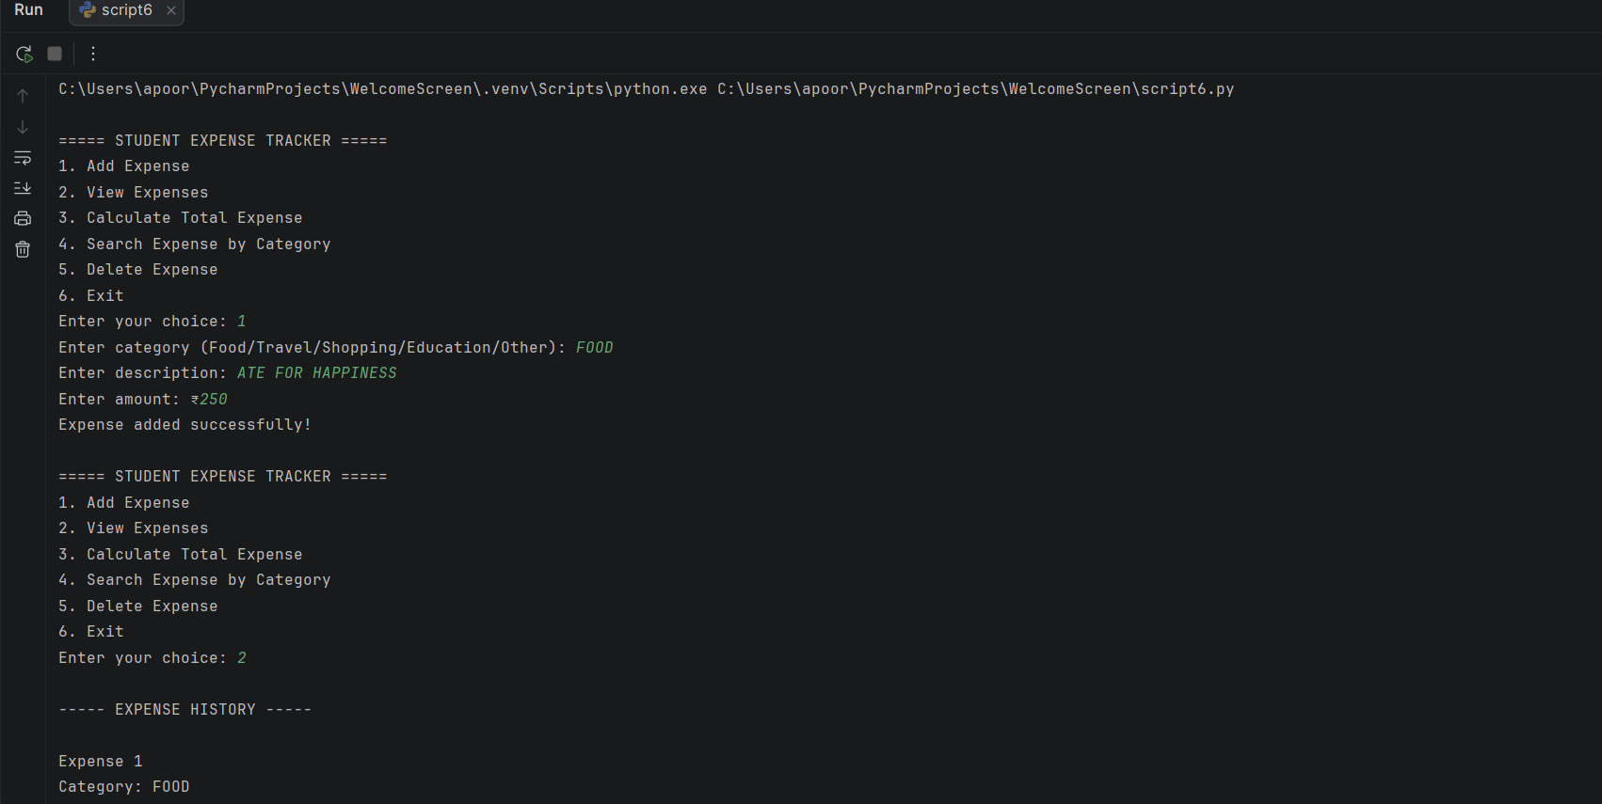
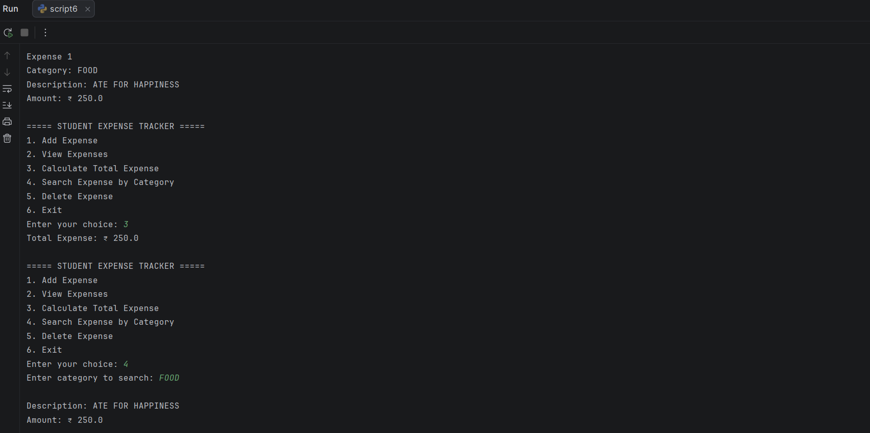
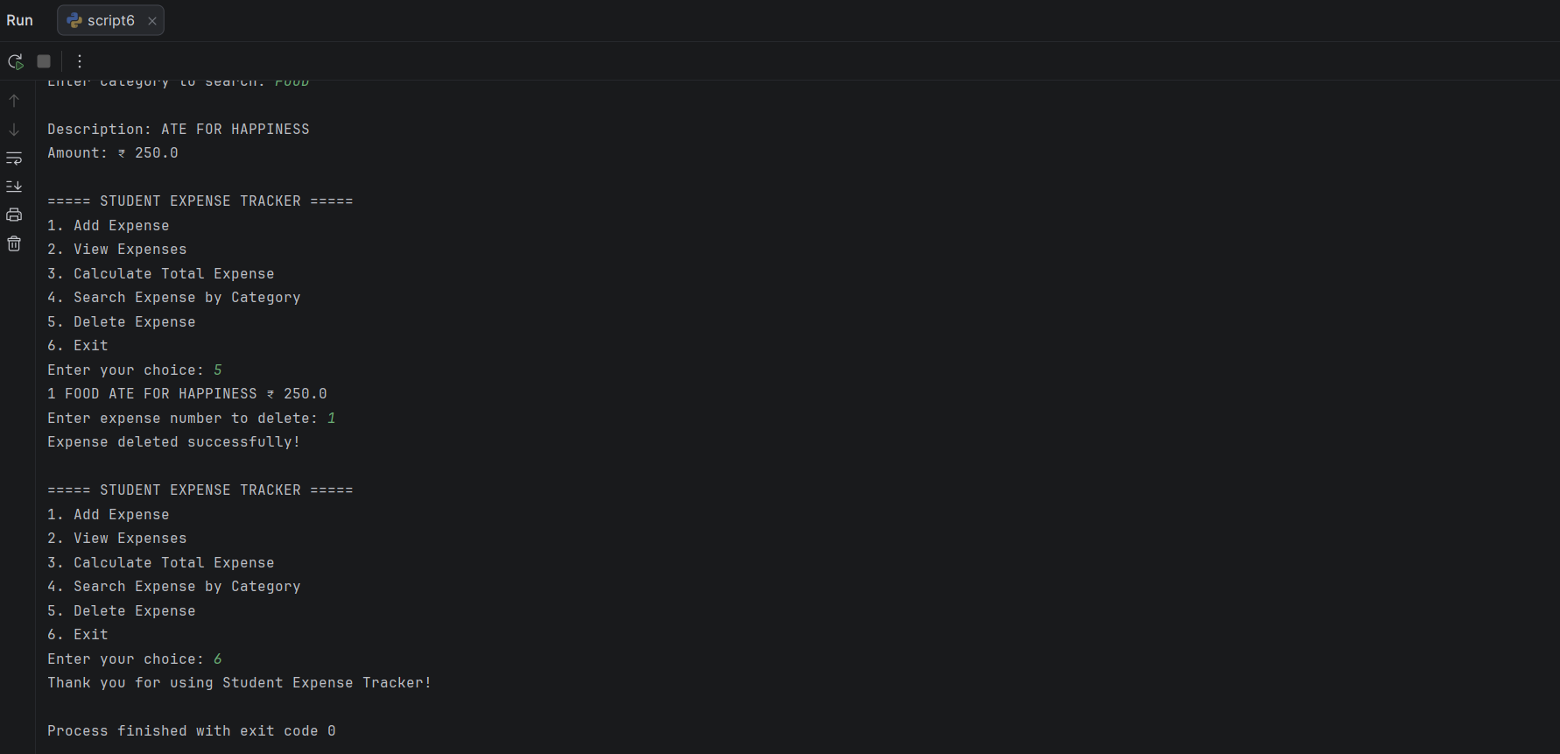

Algorithm: Student Expense Tracker
- Start
- Create an empty list called expenses.
- Display the main menu.
- Ask the user to enter their choice.
- If the choice is 1 (Add Expense):
  - Enter expense category.
  - Enter expense description.
  - Enter expense amount.
  - Store the details in the expenses list.
  - Display a success message.
- If the choice is 2 (View Expenses):
  - Check whether the list is empty.
  - If empty, display "No expenses recorded."
  - Otherwise, display all expense details.
- If the choice is 3 (Calculate Total Expense):
  - Set total = 0.
  - Add the amount of each expense to total.
  - Display the total expense.
- If the choice is 4 (Search Expense):
  - Ask the user for a category.
  - Compare the category with stored expenses.
  - Display matching expenses.
  - If no match is found, display "No expenses found."
- If the choice is 5 (Delete Expense):
  - Display all expenses with their numbers.
  - Ask the user which expense to delete.
  - Remove the selected expense.
  - Display a confirmation message.
- If the choice is 6 (Exit):
  - Display a thank-you message.
  - Stop the program.
- If an invalid choice is entered, display an error message.
- Return to the main menu after each operation.
- End.
README
Files in the Project
StudentExpenseTracker/
│
- student_expense_tracker.py
- README.md

Contains the complete Python program for the Student Expense Tracker, including adding, viewing, searching, calculating, and deleting expenses.
README.md
Contains information about the project files and instructions for running the program.
How to Run
1. Install Python
Make sure Python is installed on your computer.
Check the installation using:
python --version
2. Download or Clone the Project
Download the project files or clone the GitHub repository.
3. Open the Project
Open the project folder in PyCharm, VS Code, or any Python-supported IDE.
4. Run the Program
Open the terminal in the project folder and run:
python student_expense_tracker.py
Alternatively, open student_expense_tracker.py in your IDE and click Run.
5. Use the Program
The program will display the main menu:
1. Add Expense
2. View Expenses
3. Calculate Total Expense
4. Search Expense by Category
5. Delete Expense
6. Exit
Enter the number corresponding to the operation you want to perform.

THE END

